






EKA University of Applied Sciences,
Alberta College, Sumy State University, Ferris State University, AMBIS University and Association of Latvian Economists

invite you to participate in the International Scientific Conference

EMERGING TRENDS IN ECONOMICS, CULTURE AND HUMANITIES (ETECH2025)

APRIL 23-24, 2025, RIGA, LATVIA
VENUE: EKA, Pernavas 62, Riga, Plenary session - TBA

TOPICS: EMERGING TRENDS IN
- Sustainability and circular economy
- Social entrepreneurship
- Macroeconomics, international economics, public economics and financial economics

- Business administration, marketing and corporate finance
- Culture studies and international culture project management
- Creative industries, art and design
- Law
- ICT solutions for business, management and education

CONTACT INFORMATION

Dr.oec. Jevgenija Dehtjare, Head of the Development of the EKA Scientific Institution
Phone: (+371) +371 22 541 338, e-mail: jevgenija.dehtjare@eka.edu.lv

IMPORTANT DATES
Registration (with a short abstract) | Up to February 23, 2025
Payment of a conference fee (standard fee EUR250) | Up to March 15, 2025
Submission of a full paper | Up to March 15, 2025

REGISTRATION
The participants should register with a short abstract (1500-2500 characters) via conference electronic registration system etech.eka.edu.lv Abstract template is available for uploading in the registration system. After the notification of the abstract acceptance participants can send a full paper to the address jelena.titko@eka.edu.lv Paper template is available in the registration system.

PUBLICATION OPPORTUNITIES
Journal „Economics and Culture” (ISSN: 2255-7563 / e-ISSN: 2256-0173). Indexed by SCOPUS, ERIH+ and other services. More information at https://content.sciendo.com/view/journals/jec/jec-overview.xml
Journal “Business, Management and Economics Engineering” (ISSN: 2669-2481 / eISSN: 2669-249X). Indexed by SCOPUS, Emerging Sources Citation Index (Web of Science), ERIH+ and others. More information at http://bmee.vilniustech.lt (APC is applied EUR 484)
Journal “Marketing and Management of Innovations” (ISSN: 2218-4511 / e-ISSN: 2227-6718). Indexed by Emerging Sources Citation Index (Web of Science) and others. More information at http://mmi.fem.sumdu.edu.ua/
Journal “Virtual Economics” (ISSN: 2657-4047). Indexed by SCOPUS and others. More information at https://virtual-economics.eu/
Journal “Forum Scientiae Oeconomia” (ISSN: 2300-5947). Indexed by SCOPUS and others. More information at https://ojs.wsb.edu.pl/
Journal “Ekonomika” (ISSN 2424-6166). Indexed ERIH+, SCOPUS and others. More information at https://www.journals.vu.lt/ekonomika/
“Journal of Economics and Management” (ISSN 1732-1948). Indexed ERIH+, SCOPUS and others. More information at https://sciendo.com/journal/JEMUEKAT

CONFERENCE FEE
Standard fee till March 15, 2025* | EUR 300
Online participation** | EUR 150
Fee for accompanying person | EUR 100

*Standard fee includes: attendance of conference sessions, certificate of presentation, conference materials, coffee breaks, lunch, welcome reception on April 23, 2025, Gala Dinner on April 24, 2025, and publication of the selected papers in etECH partner journals.

** Online fee includes: virtual attendance of conference session, certificate of presentation, and publication of the selected papers in etECH partner journals.

One author can submit maximum 1 paper.
If the paper is not accepted for publishing, the conference fee will not be refunded.

Payment details:
Beneficiary name: Ekonomikas un kulturas augstskola
Beneficiary address: Pernavas 62, Riga, LV-1009, Latvia
Beneficiary registration No: 40003402986
Bank: Citadeles banka
Bank SWIFT: PARXLV22
Beneficiary IBAN (account No): LV54PARX0000350971017
Payment details: etECH2025 participation fee – Name Surname

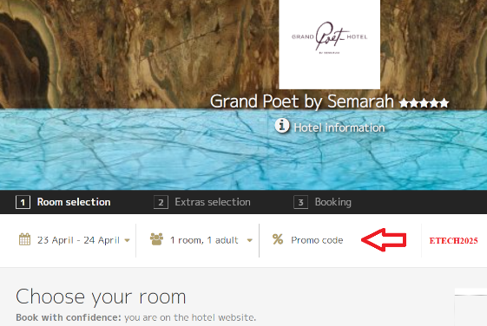
ACCOMODATION OFFERS
Special prices for ETECH participants!
Use ETECH2025 promo code!!!
Grand Poet by Semarah hotels:
Single room / Double room EUR 115/135 per night
Book online at https://grandpoet.semarahhotels.com/en/

Metropole by Semarah hotels:
Single room / Double room EUR 63/75 per night
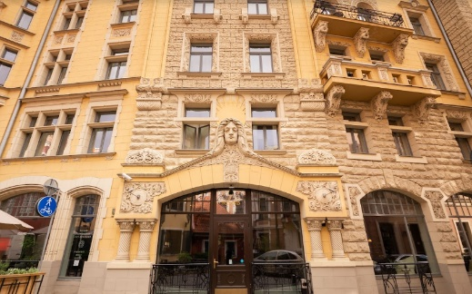
Book online: https://metropole.semarahhotels.com/

Neiburgs Hotel & Restaurant:
Single room / Double room EUR 103/121 per night
Book via e-mail: reservation@neiburgs.com

